마우스 제스처 추가

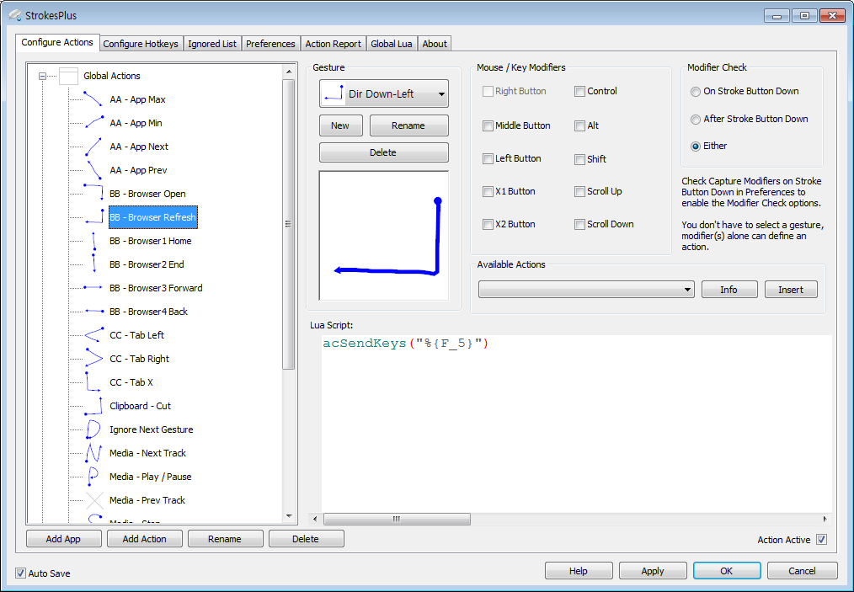

- New 버튼을 클릭

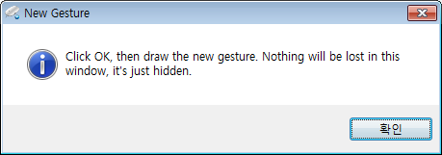

- 확인 클릭

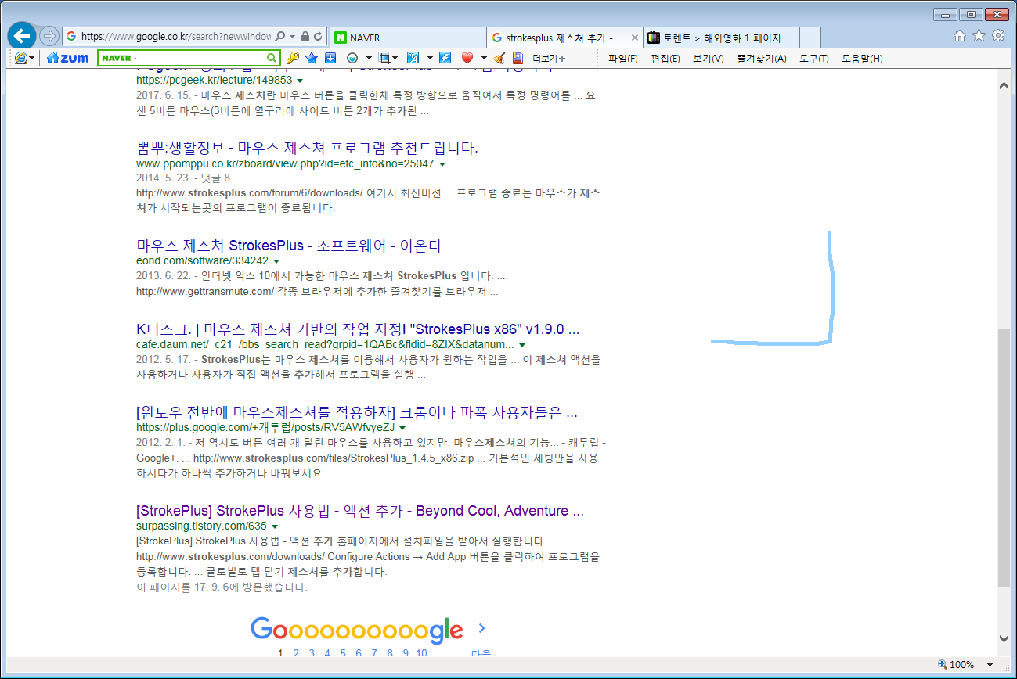

- 아무곳에 마우스로 제스처를 그림

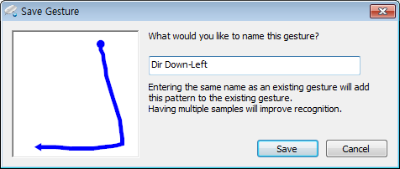

제스처명을 입력하고 저장 버튼 클릭

**Key Modifiers** (indicate the button should be pressed along with the following character, useful for sending ALT+H, which would read "%h"):  
  
**@ = WINKEY  
+ = SHIFT  
^ = CTRL  
% = ALT**

**소문자 사용 : 복사 => acSendKeys("^c")**  
**Other Functions:**  
  
{VKEY X} - Sends the VKEY specified. Useful if there's a VKEY I don't have defined. For example, {VKEY 13} is equivalent to VK_RETURN.  
See: <http://msdn.microsoft.com/en-us/library/dd375731%28v=VS.85%29.aspx>  
  
{BEEP X Y} - Beeps with a frequency of X and a duration of Y ms.  
  
{DELAY X} - Delays sending the next key of X milliseconds.  
After the delaying the following key, the subsequent keys will not be further delayed unless there is a default delay value (see DELAY=X).  
Example: {DELAY 1000} <-- delays subsequent key stroke for 1 second.  
  
{DELAY=X} - Sets the default delay value to X milliseconds. This will cause every key to be delayed X ms.  
If a value is already set and you specify {DELAY Y} you will have your following key delay Y ms but the subsequent keys will be delayed X ms.  
Example: {DELAY=1000} <-- all subsequent keys will be delayed for 1 second.  
  
**Full SendKeys listing:**  
  
{ADD} = VK_ADD  
{APPS} = VK_APPS  
{AT} = @  
{BACKSPACE} = VK_BACK  
{BKSP} = VK_BACK  
{BREAK} = VK_CANCEL  
{BROWSERBACK} = VK_BROWSER_BACK  
{BROWSERFAVORITES} = VK_BROWSER_FAVORITES  
{BROWSERFORWARD} = VK_BROWSER_FORWARD  
{BROWSERHOME} = VK_BROWSER_HOME  
{BROWSERREFRESH} = VK_BROWSER_REFRESH  
{BROWSERSEARCH} = VK_BROWSER_SEARCH  
{BROWSERSTOP} = VK_BROWSER_STOP  
{BS} = VK_BACK  
{CAPSLOCK} = VK_CAPITAL  
{CARET} = ^  
{CLEAR} = VK_CLEAR  
{DECIMAL} = VK_DECIMAL  
{DEL} = VK_DELETE  
{DELETE} = VK_DELETE  
{DIVIDE} = VK_DIVIDE  
{DOWN} = VK_DOWN  
{END} = VK_END  
{ENTER} = VK_RETURN  
{ESC} = VK_ESCAPE  
{ESCAPE} = VK_ESCAPE  
{F10} = VK_F10  
{F11} = VK_F11  
{F12} = VK_F12  
{F13} = VK_F13  
{F14} = VK_F14  
{F15} = VK_F15  
{F16} = VK_F16  
{F_1} = VK_F1  
{F_2} = VK_F2  
{F_3} = VK_F3  
{F_4} = VK_F4  
{F_5} = VK_F5  
{F_6} = VK_F6  
{F_7} = VK_F7  
{F_8} = VK_F8  
{F_9} = VK_F9  
{HELP} = VK_HELP  
{HOME} = VK_HOME  
{INS} = VK_INSERT  
{LBRACE} = {  
{LEFT} = VK_LEFT  
{LPAREN} = (  
{LWIN} = VK_LWIN  
{MEDIANEXTTRACK} = VK_MEDIA_NEXT_TRACK  
{MEDIAPLAYPAUSE} = VK_MEDIA_PLAY_PAUSE  
{MEDIAPREVTRACK} = VK_MEDIA_PREV_TRACK  
{MEDIASTOP} = VK_MEDIA_STOP  
{MULTIPLY} = VK_MULTIPLY  
{NUMLOCK} = VK_NUMLOCK  
{NUMPAD0} = VK_NUMPAD0  
{NUMPAD1} = VK_NUMPAD1  
{NUMPAD2} = VK_NUMPAD2  
{NUMPAD3} = VK_NUMPAD3  
{NUMPAD4} = VK_NUMPAD4  
{NUMPAD5} = VK_NUMPAD5  
{NUMPAD6} = VK_NUMPAD6  
{NUMPAD7} = VK_NUMPAD7  
{NUMPAD8} = VK_NUMPAD8  
{NUMPAD9} = VK_NUMPAD9  
{PERCENT} = %  
{PGDN} = VK_NEXT  
{PGUP} = VK_PRIOR  
{PLUS} = +  
{PRTSC} = VK_PRINT  
{RBRACE} = }  
{RIGHT} = VK_RIGHT  
{RPAREN} = )  
{RWIN} = VK_RWIN  
{SCROLL} = VK_SCROLL  
{SEPARATOR} - VK_SEPARATOR  
{SLEEP} - VK_SLEEP  
{SNAPSHOT} = VK_SNAPSHOT  
{SUBTRACT} - VK_SUBTRACT  
{TAB} = VK_TAB  
{TILDE} = ~  
{UP} = VK_UP  
{VOLDOWN} = VK_VOLUME_DOWN  
{VOLMUTE} = VK_VOLUME_MUTE  
{VOLUP} = VK_VOLUME_UP  
{WIN} = VK_LWIN